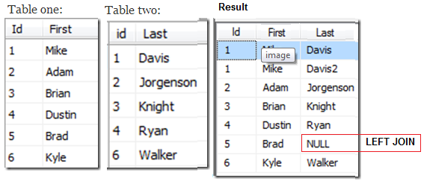

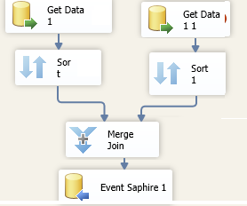

Notice the Null in ID 5 under last name. There was no match for ID 5, but since it was set to Left Outer Join we still get to keep the ID 5. If you set the Merge Join to Inner Join the ID 5 row would be dropped.

Connect both sources to the Merge Join. Set the ‘First Name’ table as the left input. You can swap the inputs by clicking the swap input button.

Set in both Connections IsSorted TRUE using the advance editor or include the SORT object

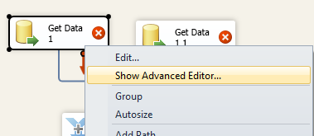

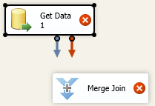

Set the first as LEFT

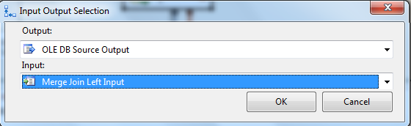

Set the second one as Right

**Then set the Merge Join (ID’s) must have been sorted previously to make this work**

